West Area Planning Committee | 6 August 2019

Application number: | 19/01298/CT3
Decision due by | 23 July 2019
Extension of time | 16 August 2019
Proposal | Erection of a two storey side extension, erection of single storey front extension and erection of single storey rear extension (amended plans).
Site address | 16 Sparsey Place, Oxford, OX2 8NL, – see Appendix 1 for site plan
Ward | Wolvercote Ward
Case officer | Sarah Orchard

Agent: | Jessop And Cook Architects | Applicant: | Oxford City Housing Ltd

Reason at Committee | The application is made on behalf of Oxford City Council

- RECOMMENDATION
  - West Area Planning Committee is recommended to:
    - approve the application for the reasons given in the report and subject to the required planning conditions set out in section 12 of this report and grant planning permission;
    - agree to delegate authority to the Acting Head of Planning Services to:
- finalise the recommended conditions as set out in this report including such refinements, amendments, additions and/or deletions as the Acting Head of Planning Services considers reasonably necessary.

- EXECUTIVE SUMMARY
  - This report considers the erection of a two storey side and rear extension, a single storey front extension and a single storey rear extension to the existing dwelling.
  - The key matters for assessment set out in this report include the following:
- Design
- Residential amenity
- Trees
  - The development is considered acceptable in design terms and will not detract from the character and appearance of the existing dwelling or surrounding area. The proposal would not have a detrimental impact on the neighbouring properties or adversely affect trees that make a significant contribution to public amenity in the area. The proposal is considered to comply with Policies CP1, CP6, CP8, CP10, NE15 and NE16 of the Oxford Local Plan, HP9 and HP14 of the Sites and Housing Plan and CS18 of the Core Strategy and the NPPF.
- LEGAL AGREEMENT
  - This application is not subject to a legal agreement.
- COMMUNITY INFRASTRUCTURE LEVY (CIL)
  - The proposal is not liable for CIL.
- SITE AND SURROUNDINGS
  - The site is located within the Wolvercote ward of Oxford to the north of the city. The property is a two storey semi-detached dwelling with a garden to the front, side and rear. To the west is the attached property at 14 Sparsey Place and to the south are dwellings located on the north side of Prior’s Forge. The site is bounded to the west by the boundary of Cutteslowe Park, which includes a number of mature trees.
  - See location plan below:
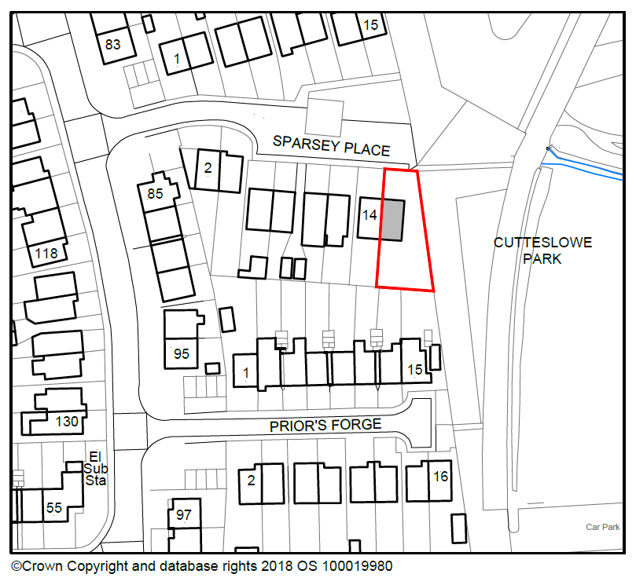
© Crown Copyright and database right 2019.
Ordnance Survey 100019348

- PROPOSAL
  - The application proposes the erection of a two storey side and rear extension, a single storey front extension and single storey rear extension to the existing dwelling. The two storey side and rear extension would project beyond the original side elevation of the dwelling by 4 metres. It would have a depth at ground floor of 8.8 metres, and would be set back from the original front elevation of the dwelling by 4 metres and project beyond the original rear elevation of the dwelling by 3.9 metres. At first floor the extension would have a reduced depth of 7.8 metres and project beyond the original rear elevation by 2.9 metres. The side extension would have an eaves height of 4.2 metres and a ridge height of 7.1 metres, which would be set down from the ridge of the main roof by 0.45 metres.
  - The proposed single storey rear extension would project beyond the original rear elevation of the dwelling by 1.1 metres across the full width of the dwelling (5.1 metres). It would have a lean-to roof with an eaves height of 2.5 metres. The proposed single storey front extension would, at its greatest extent, project beyond the original front elevation of the dwelling by 1.4 metres. It would also have a lean-to roof with an eaves height of 2.5 metres. The proposed extensions would be finished in brick with concrete tiles to the roof to match the existing dwelling.
  - Officers note that amendments to the originally submitted scheme were sought following concerns about the impact of the proposed side extension on trees along the boundary of Cutteslowe Park. The two storey side extension was moved further from the front elevation of the main dwelling in order to address these concerns. The application was re-advertised following the submission of revised plans.
- RELEVANT PLANNING HISTORY
  - The table below sets out the relevant planning history for the application site:
No relevant planning history.

- RELEVANT PLANNING POLICY
  - The following policies are relevant to the application:
Topic | National Planning Policy Framework | Local Plan | Core Strategy | Sites and Housing Plan | Emerging Oxford Local Plan
Design | 117, 118, 122, 127 | CP1  CP6  CP8  CP10 | CS18 | HP9 | DH1
Natural environment |  | NE15  NE16 |  |  | G8
Social and community |  |  |  | HP14 | H14
Miscellaneous | 38, 47 | CP13 |  | MP1

- CONSULTATION RESPONSES
  - Site notices were displayed around the application site on 6th June 2019 and an advertisement was published in The Oxford Times newspaper on 20th June 2019. Further site notices were displayed around the application site on 1st July 2019 following the submission of amended plans.
Statutory and non-statutory consultees
  - No relevant statutory or non-statutory consultees.
Public representations
  - No third party comments received.
- PLANNING MATERIAL CONSIDERATIONS
  - Officers consider the determining issues to be:
- Design
- Neighbouring amenity
- Trees

- Design
  - Policies CP1, CP8, CP10, CS18 and HP9 seek to ensure that a development is well designed and relates well to the existing house and surroundings.
  - A number of properties in the surrounding area have been altered and extended with single storey rear extensions and rear box dormers. While larger two storey extensions are less common, the dwelling sits on an unusually large plot. It is also atypical in being separated from the boundary of Cutteslowe Park by a substantial area of garden to the side (4.7 metres at minimum). The opposite dwelling at 15 Sparsey Place, and nearby similar dwellings at 15 and 16 Prior’s Forge were developed closer to the boundary of the park. As such, it is considered that the addition of a relatively substantial side extension can comfortably be accommodated within the existing streetscene, without causing harm to the character or appearance of the existing dwelling or surrounding area.
  - While relatively substantial, the side extension would be set back from the front elevation of the existing dwelling by 4 metres, and the roof of the extension would be set down from that of the main dwelling by 0.45 metres, and would therefore appear subservient to the host dwelling. The side extension would have a half dormer at first floor to the front, which would also ensure the side extension appears subservient to the main dwelling. The fenestration would form an acceptable relationship with that of the existing dwelling. The proposed two storey extension is considered to form an acceptable relationship with the host dwelling in terms of scale and form.
  - The proposed single storey front and rear extensions would be small scale additions to the existing dwelling. The rear extension would not be visible from the public realm, and is smaller in scale than existing single storey extensions to many surrounding properties. The front extension would infill between the main front elevation and an existing porch and canopy. It would be similar in appearance and scale to neighbouring front extensions at 14 and 10 Sparsey Place, and would form an acceptable relationship with the host dwelling and would not be harmful to the character and appearance of the dwelling or the streetscene. The proposed extensions would be finished in materials to match the existing dwelling, which is considered acceptable.
  - The proposals are considered to comply with policies CP1, CP8 and CP10 of the Oxford Local Plan 2001-2016, HP9 of the Sites and Housing Plan, CS18 of the Core Strategy and DH1 of the emerging Oxford Local Plan 2036, noting that it only has limited weight at this time.
- Impact on neighbouring amenity
  - Policy HP14 of the Sites and Housing Plan states that planning permission will only be granted for development that provides reasonable privacy and daylight to neighbouring properties, does not have an overbearing impact or result in a loss of outlook afforded to neighbouring properties
  - 14 Sparsey Places lies to the east of the application site. The proposals are compliant with the 45 degree line when applied to windows serving habitable rooms at no.14 and are therefore not considered to result in any unacceptable loss of daylight to these rooms. The two storey element would be separated from the shared boundary between 14 and 16 Sparsey Place by 5.1 metres, and is therefore not considered to have an overbearing impact on the garden or dwelling at no.14. The single storey rear extension would only project beyond the rear elevation of no.14 by 1.1 metres and is also not considered to have an overbearing impact on the garden or dwelling at no.14. There would be no windows on the side elevations of the first floor extension, and the proposals would not result in any loss of privacy or impact of overlooking to no.14.
  - To the south the application site lie 13 and 15 Prior’s Forge. Regard has been had to the potential impacts of overlooking and loss of privacy arising from rear-facing first floor windows in the two storey extension. At first floor, the rear elevation of the extension would be set in by 1 metre, which would ensure that a distance of 20 metres would be maintained between rear facing windows of the dwellings at 13 and 15 Prior’s Forge. The rear first floor window would also be separated from the shared boundary between 16 Sparsey Place and 13 and 15 Prior’s Forge by 8.9 metres. The proposals are therefore not considered to result in any unacceptable loss of privacy or impact of overlooking to 13 or 15 Prior’s Forge. The ground floor front and rear extensions would have no impact on the amenity of these dwellings.
  - To the west the application site is the boundary of Cutteslowe Park. There would therefore be no impact on residential amenity afforded by views in this direction.
  - The proposal is considered to comply with HP14 of the Sites and Housing Plan and H14 of the emerging Oxford Local Plan 2036, noting that it only has limited weight at this time.
- Trees
  - Policy NE15 of the Oxford Local Plan 2001-2016 states that planning permission will not be granted for any development which involves the destruction or major surgery of trees where this would have a significant adverse effect upon public amenity, unless such action can be shown to be good arboricultural practice.
  - Adjacent to the western boundary of the site there are a number of mature trees located within Cutteslowe Park.
  - Concerns were initially raised about the likely need to remove the ash tree (identified as T4 on the submitted plans) and the encroachment of the proposed two storey side and rear extension on the Root Protection Area (RPA) of another ash tree (identified on the plans as T2) and impacts on the crown of this tree. Amendments were sought which moved the proposed extension to the rear by approximately 2.7 metres.
  - Following the submission of amended plans and a revised Arboricultural Impact Assessment it is considered that the amended proposals reduce the encroachment within the RPA of ash tree T4 and result in a better spatial relationship with its crown. As a result of these changes the tree would not need to be removed as a direct result of the development. The encroachment removes a small proportion of the RPA, but it is considered that this can be compensated for within the park contiguous with the RPA and officers are satisfied that the viability of the tree would not be significantly harmed. Subject to recommended conditions, the proposals are not considered to compromise existing trees that are significant to public amenity in the area; as a result it is considered that the proposals comply with policies CP1, CP11, NE15 and NE16 of the Oxford Local Plan and G8 of the emerging Oxford Local Plan 2036, noting that it only has limited weight at this time.
- Flooding and Drainage

  - Policy CS11 of the Core Strategy relates to drainage and flooding. Whilst the proposed development is located in flood zone 1 and is at a low risk from flooding, it results in the loss of green garden land and increases impermeable areas on the site. To ensure that the proposed development does not result in an increase in surface water run-off which could contribute to flooding elsewhere, sustainable drainage would need to be incorporated into the site which would be secured by the recommended condition.
- CONCLUSION
  - Having regards to the matters discussed in the report, officers would make members aware that the starting point for the determination of this application is in accordance with Section 38 (6) of the Planning and Compulsory Purchase Act 2004 which makes clear that proposals should be assessed in accordance with the development plan unless material considerations indicate otherwise.
  - The NPPF recognises the need to take decisions in accordance with Section 38 (6) but also makes clear that it is a material consideration in the determination of any planning application (paragraph 2). The main aim of the NPPF is to deliver Sustainable Development, with paragraph 11 the key principle for achieving this aim. The NPPF also goes on to state that development plan policies should be given due weight depending on their consistency with the aims and objectives of the Framework. The relevant development plan policies are considered to be consistent with the NPPF despite being adopted prior to the publication of the framework.
  - Therefore in conclusion it would be necessary to consider the degree to which the proposal complies with the polices of the development plan as a whole and whether there are any material considerations, such as the NPPF, which are inconsistent with the result of the application of the development plan as a whole.
  - In summary, the proposed development would be an acceptable addition to the existing dwellinghouse. The proposals are suitable in design terms and comply with policies CP1, CP8 and CP10 of the Oxford Local Plan 2001-2016, HP9 of the Sites and Housing Plan, CS18 of the Core Strategy and DH1 of the emerging Oxford Local Plan 2036. The proposals would not result in any harm to neighbouring amenity and are compliant with HP14 of the Sites and Housing Plan and H14 of the emerging Oxford Local Plan. The proposals would also not compromise any trees which make an important contribution to public amenity and are compliant with NE15 and NE16 of the Oxford Local Plan and G8 of the emerging Oxford Local Plan 2036.
  - Therefore officers consider that the proposal would accord with the development plan as a whole.
Material consideration
  - The principal material considerations which arise are addressed below, and follow the analysis set out in earlier sections of this report.
  - National Planning Policy: the NPPF has a presumption in favour of sustainable development.
  - NPPF paragraph 11 states that proposals that accord with the development plan should be approved without delay, or where the development plan is absent, silent, or relevant plans are out of date, granting permission unless any adverse impacts would significantly and demonstrably outweigh the benefits when assessed against the policies in the Framework taken as a whole; or specific policies in the framework indicate development should be restricted.
  - Officers consider that the proposal would accord with the overall aims and objectives of the NPPF for the reasons set out within the report. Therefore in such circumstances, paragraph 11 is clear that planning permission should be approved without delay. This is a significant material consideration in favour of the proposal.
  - Officers would advise members that, having considered the application carefully, the proposal is considered to be acceptable in terms of the aims and objectives of the National Planning Policy Framework and relevant policies of the Oxford Core Strategy 2026, and Oxford Local Plan 2001-2016, and the emerging Local Plan 2036, when considered as a whole, and that there are no material considerations that would outweigh these policies.
  - Therefore it is recommended that the Committee resolve to grant planning permission for the development proposed subject to the conditions set out in Section 12 of this report.
- CONDITIONS
1. Time Limit
The development to which this permission relates must be begun not later than the expiration of three years from the date of this permission.
Reason: In accordance with Section 91(1) of the Town and Country Planning Act 1990 as amended by the Planning Compulsory Purchase Act 2004.
2. Develop in Accordance with Approved Plans
The development permitted shall be constructed in complete accordance with the specifications in the application and approved plans listed below, unless otherwise agreed in writing by the local planning authority.
Reason: To avoid doubt and to ensure an acceptable development as indicated on the submitted drawings in accordance with policy CP1 of the Oxford Local Plan 2001-2016.

3. Materials
The materials to be used in the proposed development shall be as specified in the application hereby approved. There shall be no variation of these materials without the prior written consent of the local planning authority.
Reason: To ensure that the development is visually satisfactory as require by policy CP1 of the Oxford Local Plan 2001-2016.
4. Drainage and SUDs
All Impermeable areas of the proposed development, including roofs, driveways, and patio areas shall be drained using Sustainable Drainage measures (SuDS).
This may include the use of porous pavements and infiltration, or attenuation storage to decrease the run off rates and volumes to public surface water sewers and thus reduce flooding.
Soakage tests shall be carried out in accordance with BRE Digest 365 or similar approved method to prove the feasibility/effectiveness of soakaways or filter trenches.
Where infiltration is not feasible, surface water shall be attenuated on site and discharged at a controlled discharge rate no greater than prior to development using appropriate SuDS techniques and in consultation with the sewerage undertaker where required.
If the use of SuDS are not reasonably practical, the design of the surface water drainage system shall be carried out in accordance with Approved Document H of the Building Regulations.
The drainage system shall be designed and maintained to remain functional, safe, and accessible for the lifetime of the development.
Oxford City Council SuDS Design Guide can be found at www.oxford.gov.uk/floodriskforplanning
Reason: To avoid increasing surface water run-off and volumes to prevent an increase in flood risk in accordance with policies CS11 of the Oxford Core Strategy 2011-2026
5. Tree Protection Measures
The development shall be carried out in strict accordance with the approved methods of working and approved tree protection measures contained within the planning application details unless otherwise agreed in writing by the Local Planning Authority.
Reason: To protect retained trees during construction. In accordance with policies CP1, CP11 and NE16 of the Adopted Local Plan 2001-2016.
INFORMATIVES:

1 In accordance with guidance set out in the National Planning Policy Framework, the Council tries to work positively and proactively with applicants towards achieving sustainable development that accords with the Development Plan and national planning policy objectives. This includes the offer of pre-application advice and, where reasonable and appropriate, the opportunity to submit amended proposals as well as time for constructive discussions during the course of the determination of an application. However, development that is not sustainable and that fails to accord with the requirements of the Development Plan and/or relevant national policy guidance will normally be refused. The Council expects applicants and their agents to adopt a similarly proactive approach in pursuit of sustainable development.

- APPENDICES
- Appendix 1 – Block plan

- HUMAN RIGHTS ACT 1998
  - Officers have considered the implications of the Human Rights Act 1998 in reaching a recommendation to approve this application. They consider that the interference with the human rights of the applicant under Article 8/Article 1 of Protocol 1 is justifiable and proportionate for the protection of the rights and freedom of others or the control of his/her property in this way is in accordance with the general interest.
- SECTION 17 OF THE CRIME AND DISORDER ACT 1998
  - Officers have considered, with due regard, the likely effect of the proposal on the need to reduce crime and disorder as part of the determination of this application, in accordance with section 17 of the Crime and Disorder Act 1998. In reaching a recommendation to grant planning permission, officers consider that the proposal will not undermine crime prevention or the promotion of community.

